**Lab Practical #05:**

Study the application layer protocol DNS, DHCP, FTP.

**Practical Assignment #05:**

1. **Implement the application layer protocol DNS, DHCP, and FTP. Also check connectivity between them using ping command or PDU utility.**

**Instructions:**

1. Protocol-wise configuration setup screenshot.
2. Mention IP address of each pc as label.
3. Ping command or PDU screenshot between two pcs.

# HTTP – Protocol Configuration :

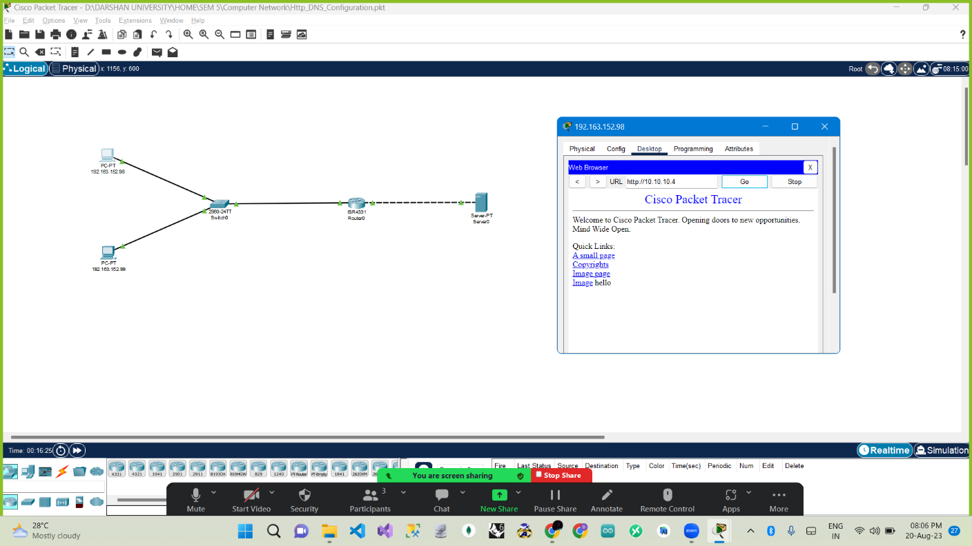

# DNS Configuration :

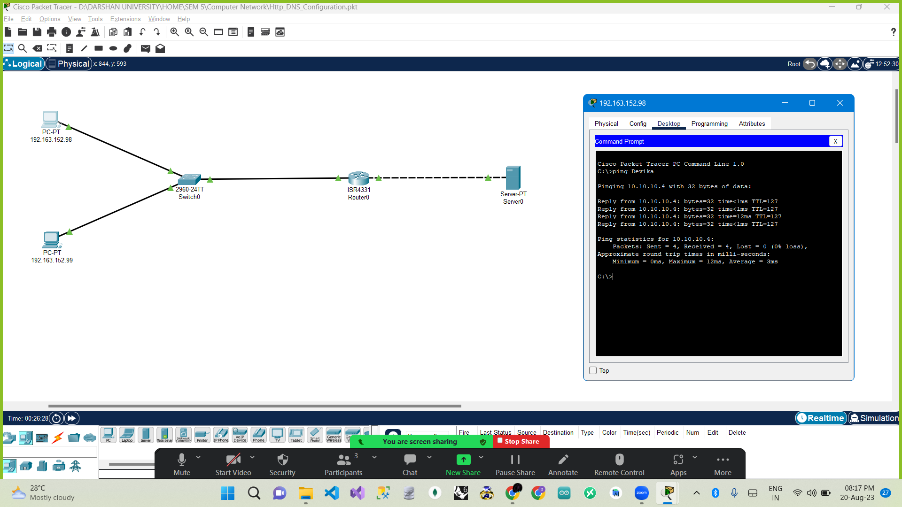

# FTP Configuration :